**ASSIGNMENT # 2**

**Perform linear or polynomial Regression is upto you on the Given dataset and predict brain weight from head size**

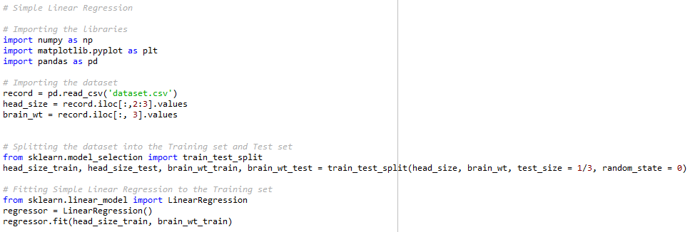

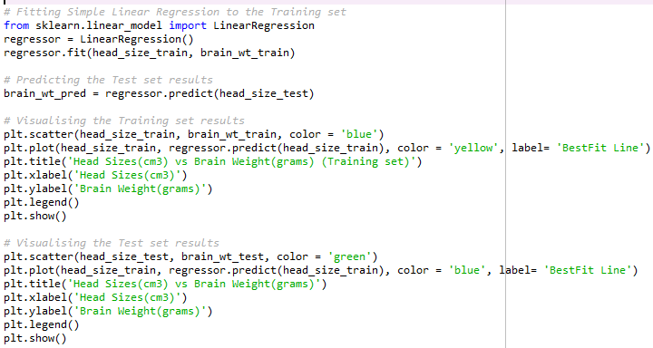

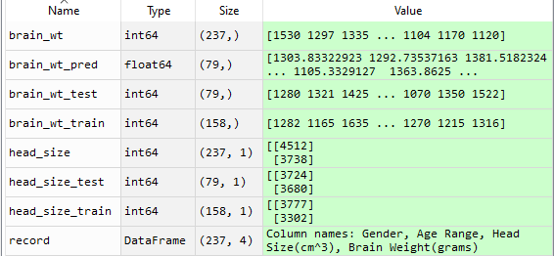

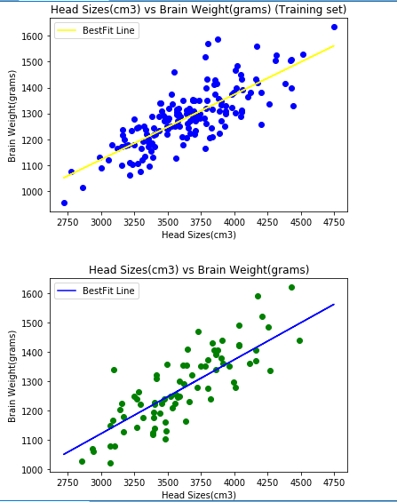

**CLASS TASK:   
CREATE TWO RANDOM ARRAYS A AND B, AND MULTIPLY THEM. GET THEIR RESULT IN C AND ADD 1 TGO EVERY ELEMENT OF C.**

